CO1-ASSESSMENT TOOL-3

NAME:K.V.SAI KRISHNA
REG.NO:192325037
COURSE: Deep Learning
COURSE CODE: MLAO406

Experiment 1:
Aim: To demonstrate confusion matrix using python
Program:
import numpy as np
from sklearn.metrics import confusion_matrix
import seaborn as sns
import matplotlib.pyplot as plt
actual = np.array(['Dog', 'Dog', 'Dog', 'Not Dog', 'Dog', 'Not Dog', 'Dog', 'Dog', 'Not Dog', 'Not Dog'])
predicted = np.array(['Dog', 'Not Dog', 'Dog', 'Not Dog', 'Dog', 'Dog', 'Dog', 'Dog', 'Not Dog', 'Not Dog'])
# Explicitly define labels to ensure correct alignment in the confusion matrix
labels = ['Dog', 'Not Dog']
conf_matrix = confusion_matrix(actual, predicted, labels=labels)
sns.heatmap(
conf_matrix,
annot=True,
fmt='g',
xticklabels=labels,
yticklabels=labels,
cmap='RdPu'
)
plt.ylabel("Prediction", fontsize=16)
plt.xlabel("Actual", fontsize=16)
plt.title("Confusion Matrix", fontsize=20)
plt.show()
OUTPUT:

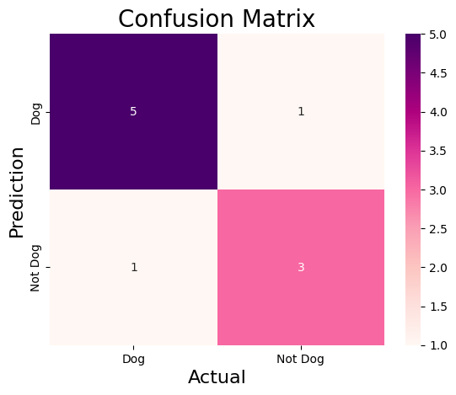

Experiment 2:
Aim: To demonstrate 2 class confusion matrix using python
Program:
import pandas as pd
import matplotlib.pyplot as plt
import seaborn as sns
from sklearn.datasets import load_wine
from sklearn.model_selection import train_test_split
from sklearn.tree import DecisionTreeClassifier
from sklearn.metrics import (
accuracy_score,
f1_score,
precision_score,
recall_score,
classification_report,
confusion_matrix
)
wine = load_wine()
data = pd.DataFrame(data=wine.data, columns=wine.feature_names)
data['Target'] = wine.target
data = data[data['Target'] != 2]
x = data.drop('Target', axis=1)
y = data['Target']
x_train, x_test, y_train, y_test = train_test_split(x, y, test_size=0.3, random_state=1)
model = DecisionTreeClassifier(random_state=1)
model.fit(x_train, y_train)
y_pred = model.predict(x_test)
accuracy = accuracy_score(y_test, y_pred)
print("accuracy:", accuracy)
class_report = classification_report(y_test, y_pred, target_names=wine.target_names[:2])
print("Classification Report:\n", class_report)
precision = precision_score(y_test, y_pred)
recall = recall_score(y_test, y_pred)
f1 = f1_score(y_test, y_pred)

print(f"Precision: {precision:.2f}")
print(f"Recall: {recall:.2f}")
print(f"F1 Score: {f1:.2f}")
conf_matrix = confusion_matrix(y_test, y_pred)
plt.figure(figsize=(8, 6))
sns.heatmap(
conf_matrix,
annot=True,
fmt='d',
cmap='PuBuGn',
xticklabels=wine.target_names[:2],
yticklabels=wine.target_names[:2]
)
plt.xlabel("predicted label")
plt.ylabel("true label")
plt.title("confusion matrix")
plt.show()
OUTPUT:
accuracy: 0.9743589743589743
Classification Report:
precision recall f1-score support
class_0 1.00 0.94 0.97 17
class_1 0.96 1.00 0.98 22
accuracy 0.97 39
macro avg 0.98 0.97 0.97 39
weighted avg 0.98 0.97 0.97 39

Precision: 0.96
Recall: 1.00
F1 Score: 0.98
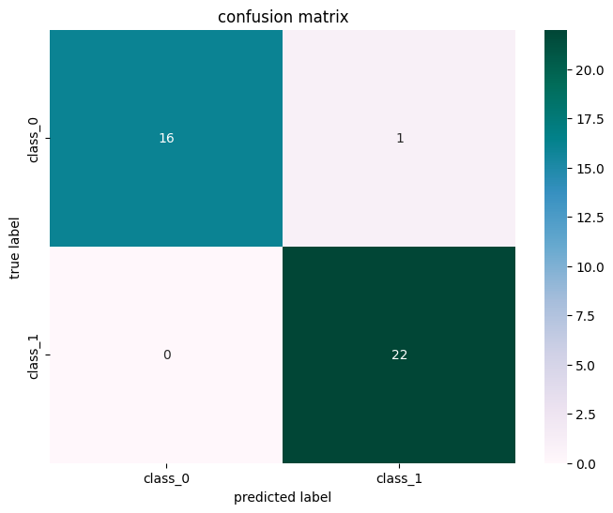

Experiment 3:
Aim: To analyse the performance of a multi class confusion matrix by using choosen database with python code .
Program:
from sklearn.datasets import load_digits
from sklearn.model_selection import train_test_split
from sklearn.ensemble import RandomForestClassifier
from sklearn.metrics import confusion_matrix
import seaborn as sns
import matplotlib.pyplot as plt
from sklearn.metrics import accuracy_score, precision_score, recall_score, f1_score
X, y = load_digits(return_X_y=True)
X_train, X_test, y_train, y_test = train_test_split(X, y, test_size=0.25, random_state=23)
clf = RandomForestClassifier(random_state=23)
clf.fit(X_train, y_train)
y_pred = clf.predict(X_test)
cm = confusion_matrix(y_test, y_pred)
plt.figure(figsize=(8, 6))
sns.heatmap(cm, annot=True, fmt='g', cmap="winter")
plt.ylabel('Prediction', fontsize=13)
plt.xlabel('Actual', fontsize=13)
plt.title('Confusion Matrix', fontsize=17)
plt.show()
accuracy = accuracy_score(y_test, y_pred)
precision = precision_score(y_test, y_pred, average='weighted')
recall = recall_score(y_test, y_pred, average='weighted')
f1 = f1_score(y_test, y_pred, average='weighted')
print("Accuracy :", accuracy)
print("Precision :", precision)
print("Recall :", recall)
print("F1 Score :", f1)
OUTPUT:

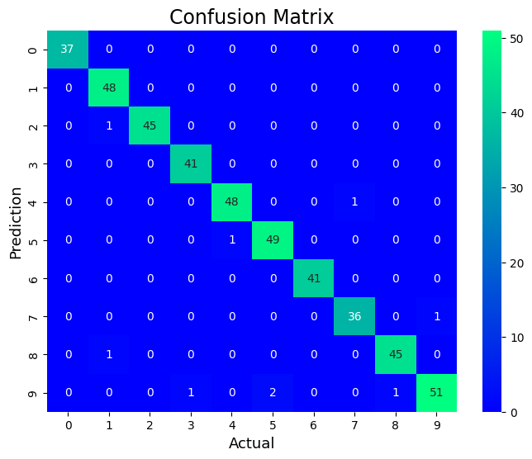
Accuracy : 0.98
Precision : 0.9801896286719816
Recall : 0.98
F1 Score : 0.9799237684030243

Experiment 4:
Aim: To analyse the performance of a over fitting by using choosen database with python code .
Program:
import numpy as np
import matplotlib.pyplot as plt
from sklearn.pipeline import Pipeline
from sklearn.preprocessing import PolynomialFeatures
from sklearn.linear_model import LinearRegression
from sklearn.model_selection import cross_val_score
def true_fun(X):
return np.cos(1.5 * np.pi * X)
np.random.seed(0)
n_samples = 30
degrees = [1, 4, 15]
X = np.sort(np.random.rand(n_samples))
y = true_fun(X) + np.random.randn(n_samples) * 0.1
plt.figure(figsize=(14, 5))
for i in range(len(degrees)):
ax = plt.subplot(1, len(degrees), i + 1)
plt.setp(ax, xticks=(), yticks=())
polynomial_features = PolynomialFeatures(degree=degrees[i], include_bias=False)
linear_regression = LinearRegression()
pipeline = Pipeline(
[
("polynomial_features", polynomial_features),
("linear_regression", linear_regression),
]
)
pipeline.fit(X[:, np.newaxis], y)
scores = cross_val_score(
pipeline, X[:, np.newaxis], y, scoring="neg_mean_squared_error", cv=10
)
X_test = np.linspace(0, 1, 100)
plt.plot(X_test, pipeline.predict(X_test[:, np.newaxis]), label="Model")
plt.plot(X_test, true_fun(X_test), label="True function")
plt.scatter(X, y, edgecolor="y", s=20, marker="^", label="Samples")
plt.xlabel("x")
plt.ylabel("y")
plt.xlim((0, 1))
plt.ylim((-2, 2))
plt.legend(loc="best")
plt.title(
"Degree {}\nMSE = {:.2e}(+/- {:.2e})".format(
degrees[i], -scores.mean(), scores.std()
)
)

plt.tight_layout()
plt.show()

OUTPUT:

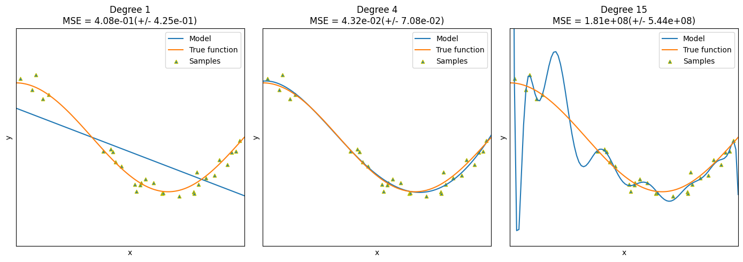
Experiment 5:
Aim: To demonstrate the performance of a linear regression by using choosen database with python code .
Program:
import pandas as pd
import matplotlib.pyplot as plt
from sklearn.datasets import load_iris
from sklearn.model_selection import train_test_split
from sklearn.linear_model import LinearRegression
from sklearn.metrics import mean_squared_error
iris = load_iris()
data = pd.DataFrame(data=iris.data, columns=iris.feature_names)
data['species'] = iris.target
print(data.head())
X = data[['sepal length (cm)']]
y = data['sepal width (cm)']

X_train, X_test, y_train, y_test = train_test_split(X, y, test_size=0.3, random_state=42)
model = LinearRegression()
model.fit(X_train, y_train)
y_pred = model.predict(X_test)
mse = mean_squared_error(y_test, y_pred)
print(f'Mean Squared Error on test set: {mse:.2f}')
plt.figure(figsize=(10, 6))
plt.scatter(X_test, y_test, color='r', marker='*', label='Actual')
# Sort X_test and corresponding y_pred for a clean line plot
sort_indices = X_test['sepal length (cm)'].argsort()
plt.plot(X_test.iloc[sort_indices], y_pred[sort_indices], color='y', linewidth=3, label='Predicted')
plt.xlabel('Sepal Length (cm)')
plt.ylabel('Sepal Width (cm)')
plt.title('Linear Regression: Sepal Width vs Sepal Length')
plt.legend()
plt.show()
new_sample = pd.DataFrame([[5]], columns=['sepal length (cm)'])
predicted_width = model.predict(new_sample)
print(f'The predicted sepal width for sepal length {new_sample.values.tolist()} is {predicted_width[0]:.2f} cm')
OUTPUT:
sepal length (cm) sepal width (cm) petal length (cm) petal width (cm) \
0 5.1 3.5 1.4 0.2
1 4.9 3.0 1.4 0.2
2 4.7 3.2 1.3 0.2
3 4.6 3.1 1.5 0.2
4 5.0 3.6 1.4 0.2

species
0 0
1 0
2 0
3 0
4 0
Mean Squared Error on test set: 0.23
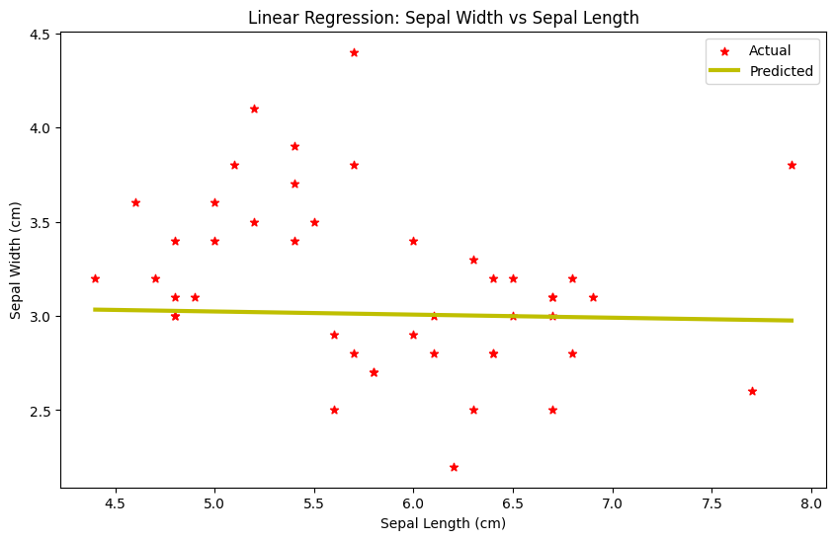
The predicted sepal width for sepal length [[5]] is 3.02 cm

